**Project #4**

**Implementation and Partial Demo**

**RSVPme**

Joshua Lorenz, Tyler Johnson, Caleb Horn, Fugang Deng, Chen Zhang

**Project 4**

1. **Project Description**

This project is built around changing an issue we see with standard social media; many people are preferring virtual interactions over physical interactions. RSVPme is a new social media focused on making in-person interactions much easier to organize and find. We plan on building an application that is able to create and view events that are either organized privately by friends or publicly by organizations that are willing to pay.

As for private events, we expect that a user is able to create an event and send an invitation to any subset of their friends. Their friends are able to then see the event and all of its details with the option to go or not. Additional features such as being able to communicate with those invited should be included.

On the other hand, public events allow organizations to advertise events that they are hosting to everyone. For example, TTU is able to show events like football games on the app and users are able to find all the details of the event on the app. We plan to implement additional tools for those hosting public events such as the ability to have a separate section to post notifications about the event that only organizers are able to talk in.

1. **Implementation Overview**

For this project we have split the projects into different parts which all of us have the most experience or interest in. With this being said, we are open to any of us jumping in for assistance or including ideas for any part of the project. We also used agile methodology by having a select few goals to finish by the time project 4 was done and we are planning on continuing this idea into the future.

Currently the project has been worked on mostly by Lex who is our member with the most experience creating projects like this. We intentionally planned this due to his experience and need for a sturdy foundation with the lack of confusion due to multiple people working on still a small project. Now that the base project is created with well working components, the rest of our group will now fleshout bigger ideas into the project. In section 8 we go more in depth about who is planning on working on what.

To get the point we are in the project we used

* React Native for simple cross platform app development
* MongoDB to store data like user IDs and events
* Google Maps API to display a map and events on the map

1. **Project implementation update**

At this moment, our team has already accomplished several functions of our RSVPme app. We already finished the add event function to the server and delete the events from the server for the event part of our team application. Also, for the UI part, we finished displaying events on the screen, which means fetching events from the server. Next, we have the function like displaying the event's location which is associated with the Google Map API we have. Finally, in terms of the adding friends part, we have the add friend by ID and remove friend by ID functions accomplished so far.

Since we have difficult conditions due to the situation of Covid-19, the team cannot hold any face to face meeting as soon as possible. And, each team member’s schedule is very busy and most of us are in the last semester to graduate. Everyone has a lot of things to do daily. We are on the right track to complete the project with the time budget. However, we are sure that we can do better after we have a more specific plan in the future.

1. **Functionalities implemented**

RSVPme currently has the following functionalities:

1. Create event

We used the Rest API to communicate with our web server and update the MongoDB database when an event is created. Each field has rules for how many characters it requires as well as formatting for dates.

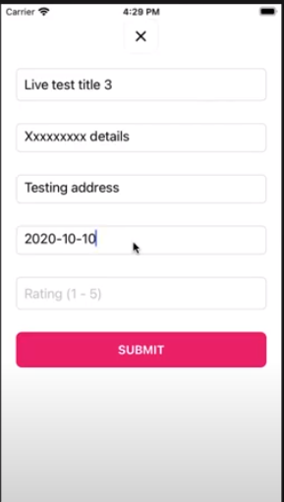 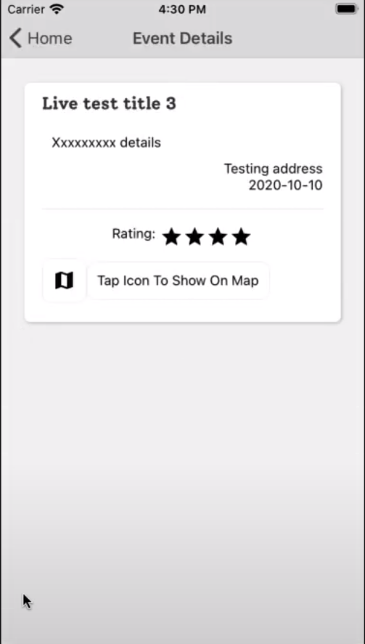

1. Google maps (navigation)

Users are able to navigate the map with the standard pinch to zoom and tap to drag features.

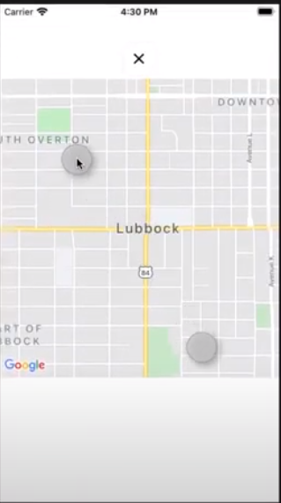 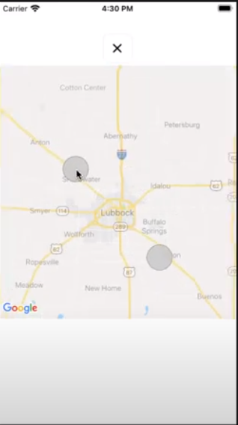

1. Menu

We added a menu button for future navigation of different pages and settings.

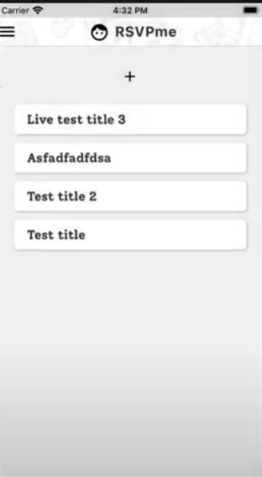 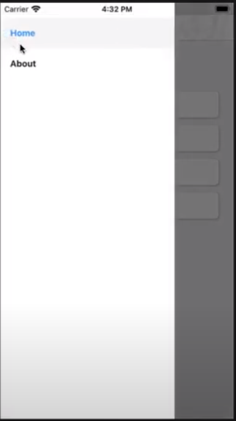

1. **Functionalities currently being implemented**

We are currently working on implementing the ability for users to delete an event they have created. We expect to have a notification prompting the user to be sure they want to delete the event so that they don’t accidentally delete their event. Also, we are working on a pin system for the map. Ideally, we want the pins for all the events to show up on the map if you are looking at a part of the map where there are events. We would also like to have a quick overview of the event to pop out of the pin when a user taps on a pin. Another major feature we are hammering out is the user authentication service. Since RSVPme is somewhat of a social media application, we will need to have a login system for our users.

1. **Functionalities remaining**

We have two major functionalities that are yet to be implemented. Those are QR-code generation/scanning and group messaging. We would like to put our own spin on the QR-code images somewhat like Snapchat has done, but we will likely use standard QR-codes for simplicity. We are currently researching ways to implement this functionality into our application. Also, we intend to have group messaging for both friends and events. This will be a key feature for our application.

1. **Implementation issue**

The biggest issue that we are facing right now is getting the event creation to work well with google maps. We plan on attempting to show a snapshot of the map below during the creation of the event for clarity, as well as putting pins on the map after creation. Right now the map is clunky to use as well, so we will need to make it easier to navigate. The user interface overall will need a facelift before the final release as well, but we have a good foundation implemented already for this prototype.

1. **Each member contribution**

**Caleb:**

Will implement the calendar functionality, as well as figure out how to do the group messaging system, and help with UI implementation/cleanup.

**Lex:**

Did most of the prototype, laid the groundwork for future implementation in the front and backend.

**Tyler:**

Will work on OAuth, google maps frontend, and cleaning up ui.

**Josh:**

Will help with the group messaging system and implementing QR-code generating/reading.

**James:**

Will implement notifications.